OBSERVATION1

When entered alphabet in customer name field, error should be different for example: minimum 2 alphabets required.1

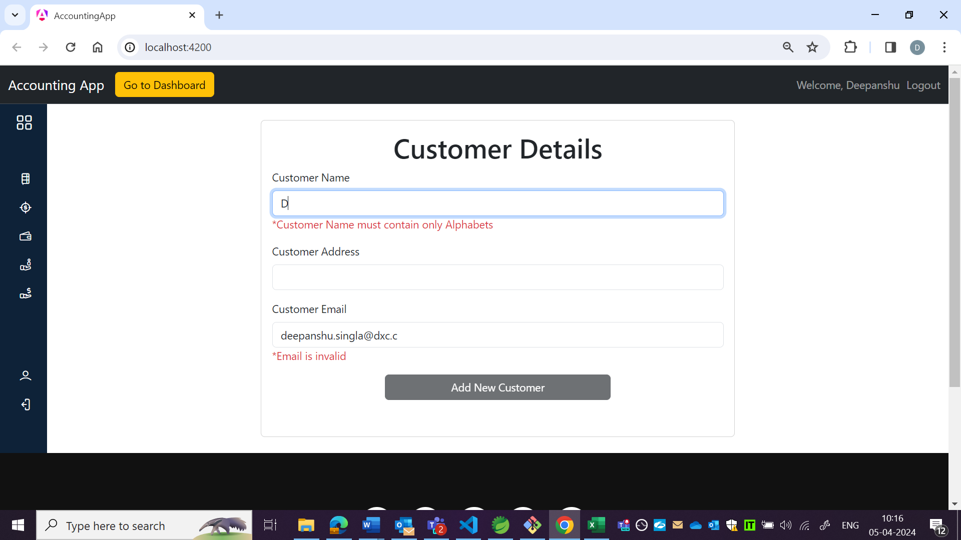

OBSERVATION2:

Whenever clicking on back icon, instead of going to previous screen it is navigation to homepage. **Back and forth functionality is not working.**

**(Reproducing for all pages in application**)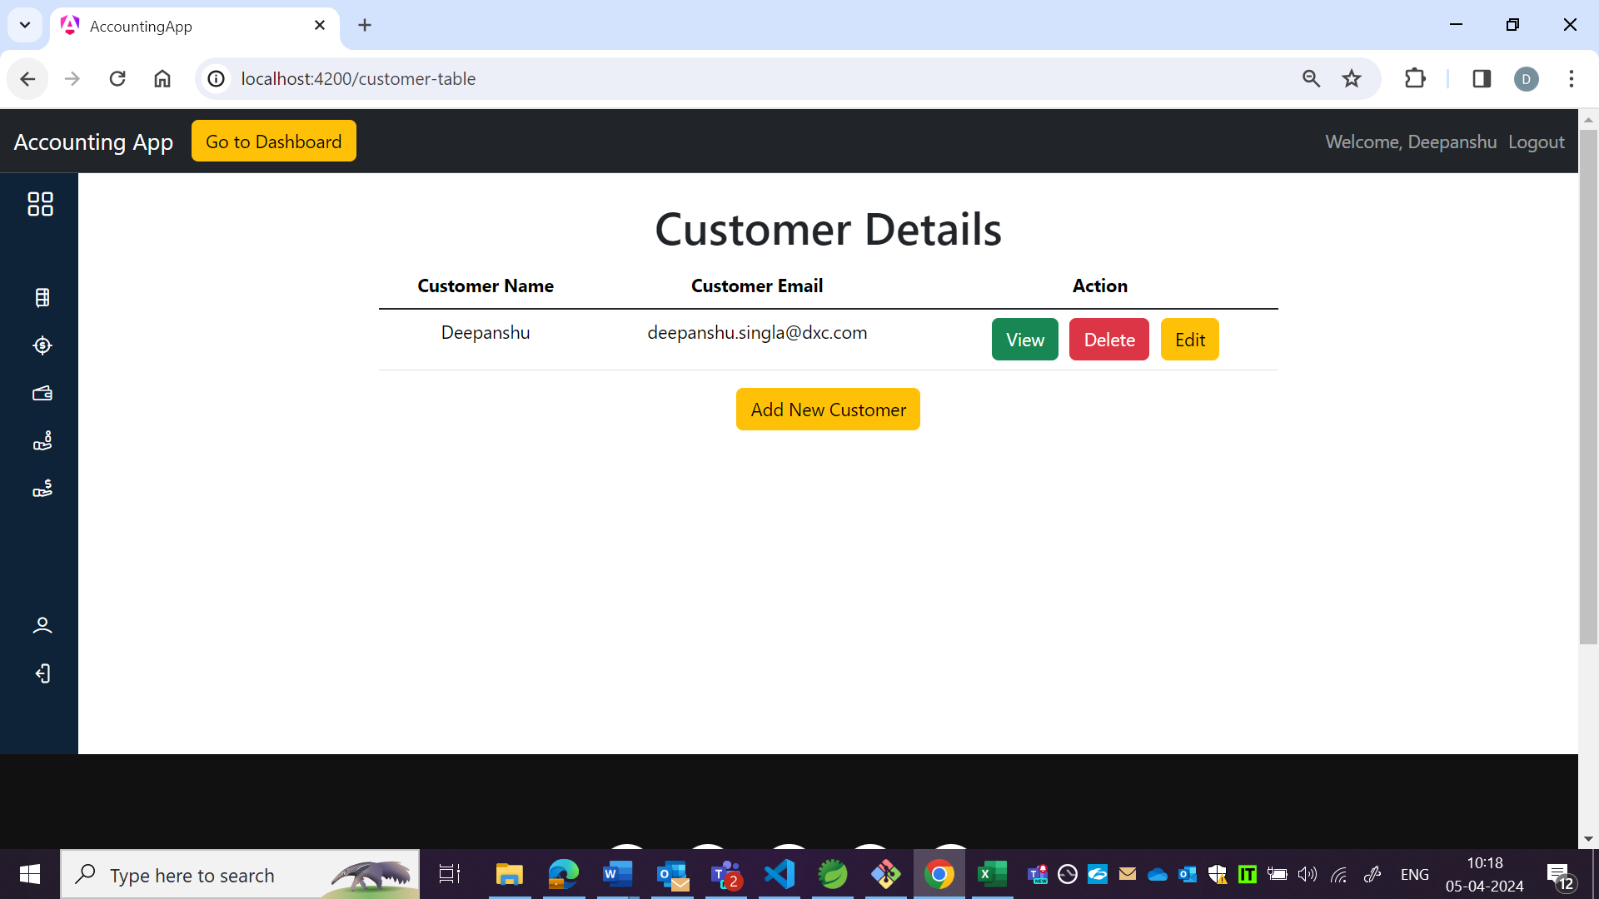

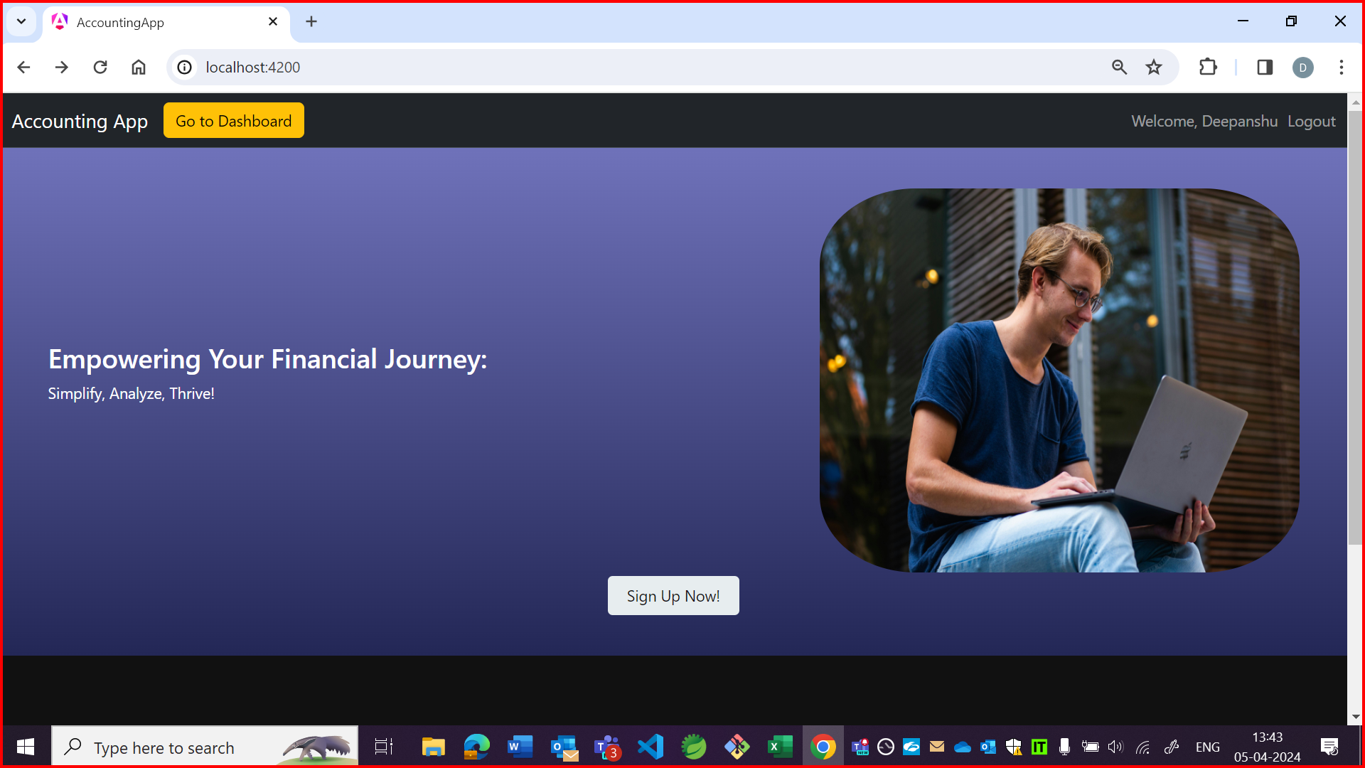

OBSERVATION3:

Address is not getting updated.

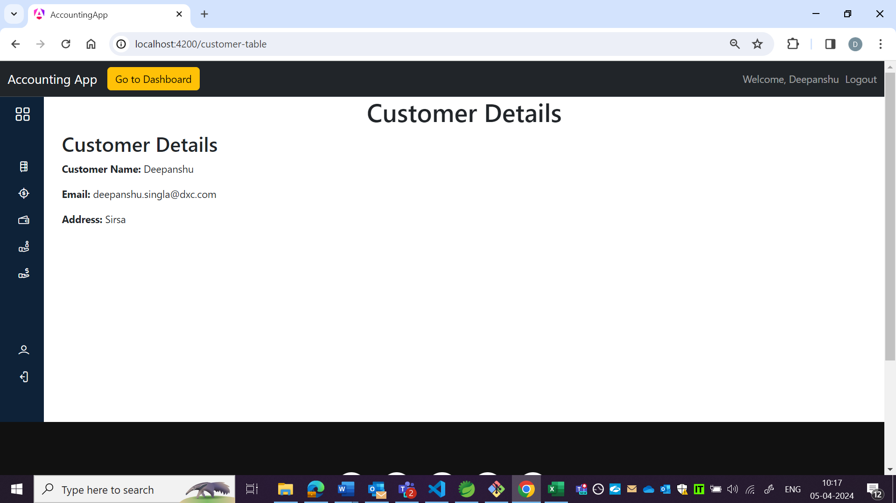

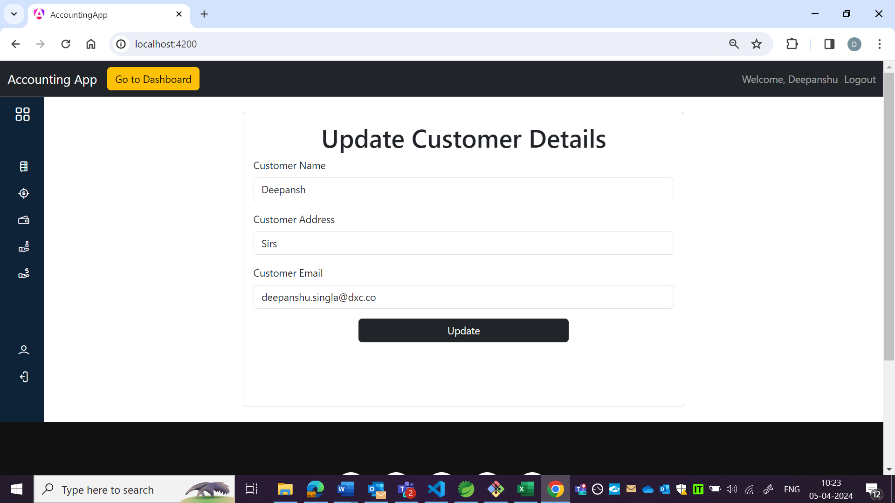

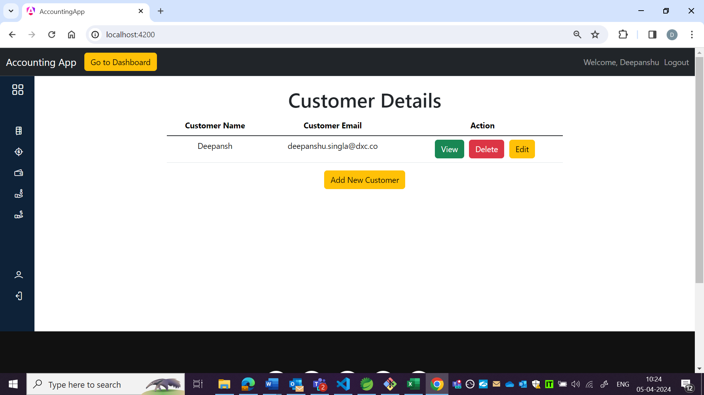

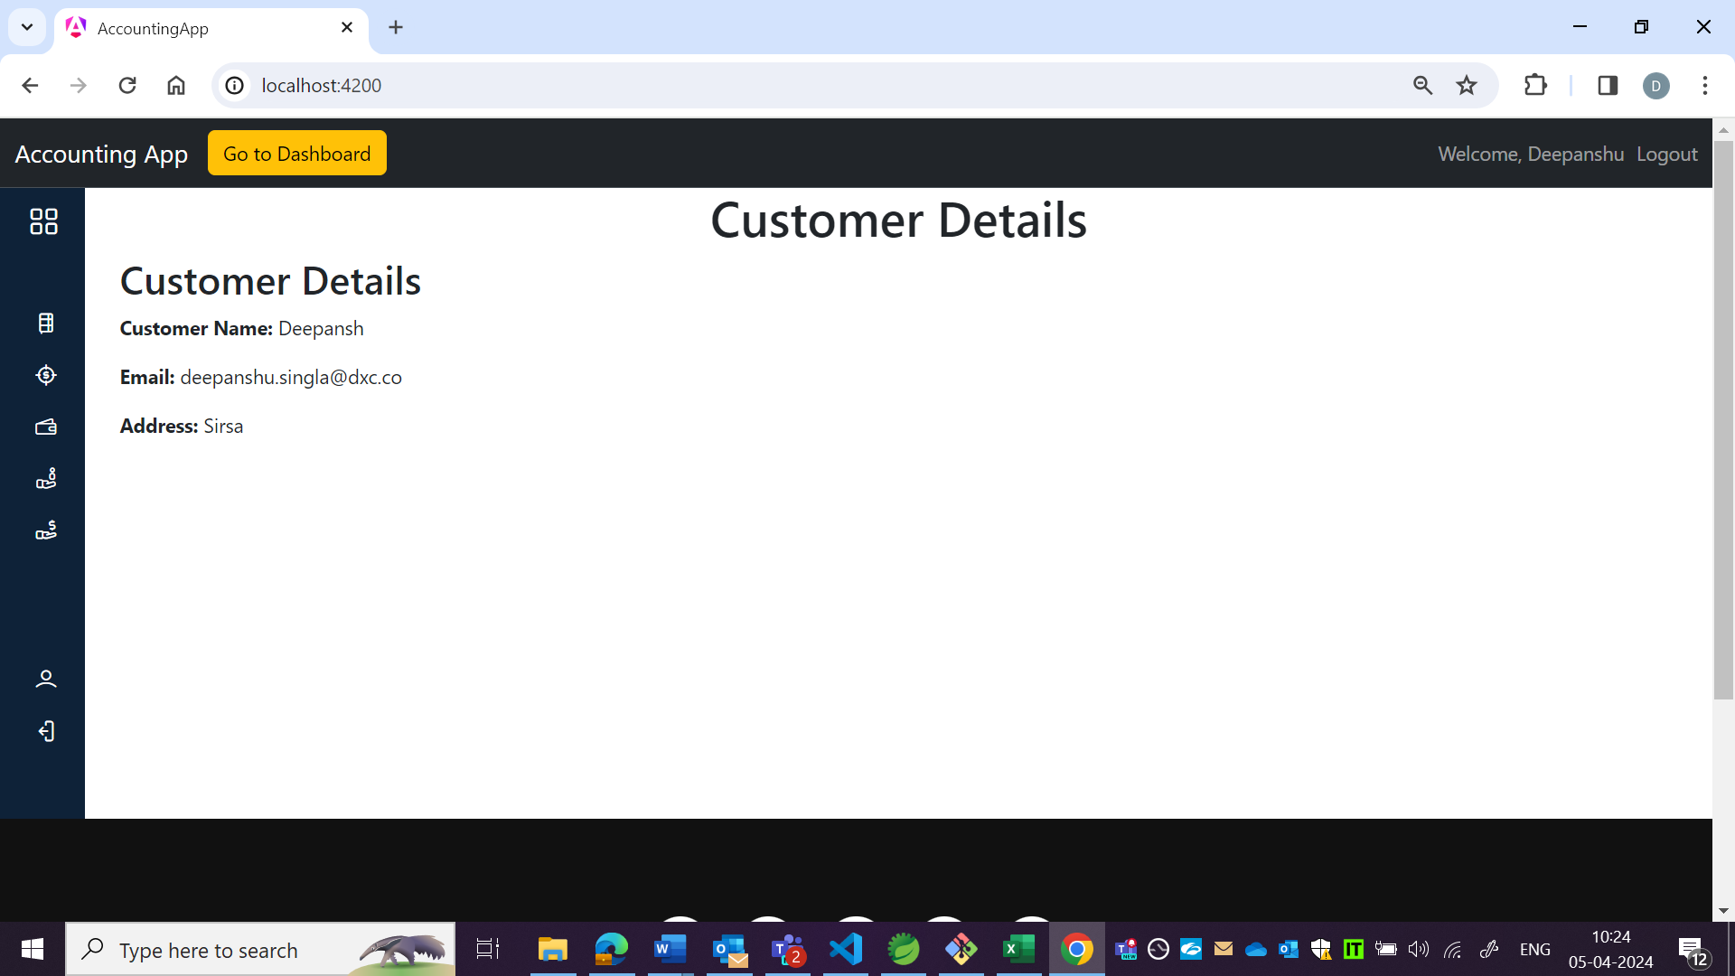

OBSERVATION4:

As per US, sort and filter functionality is not there.

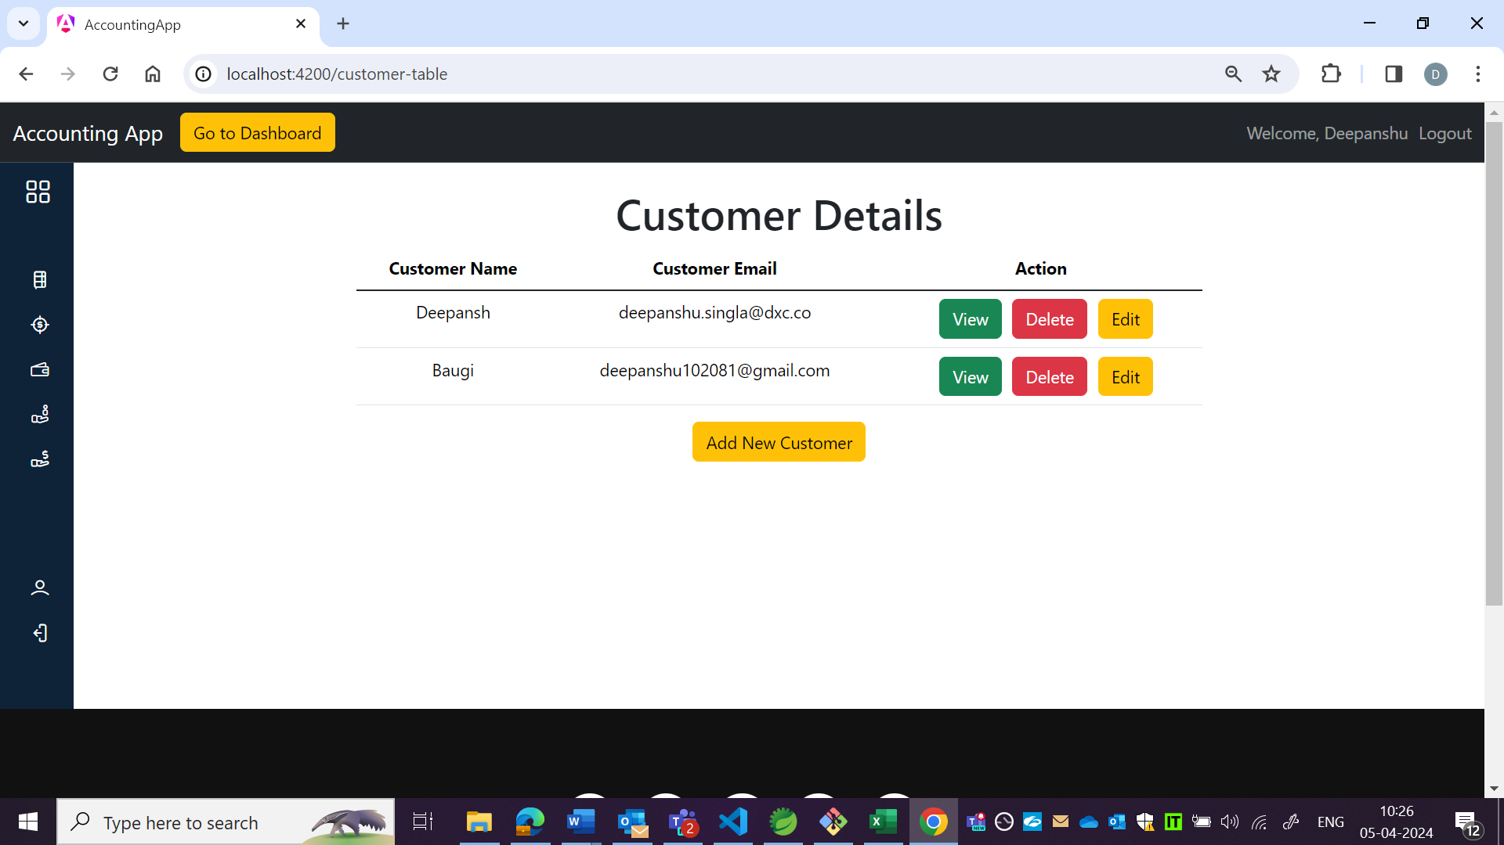

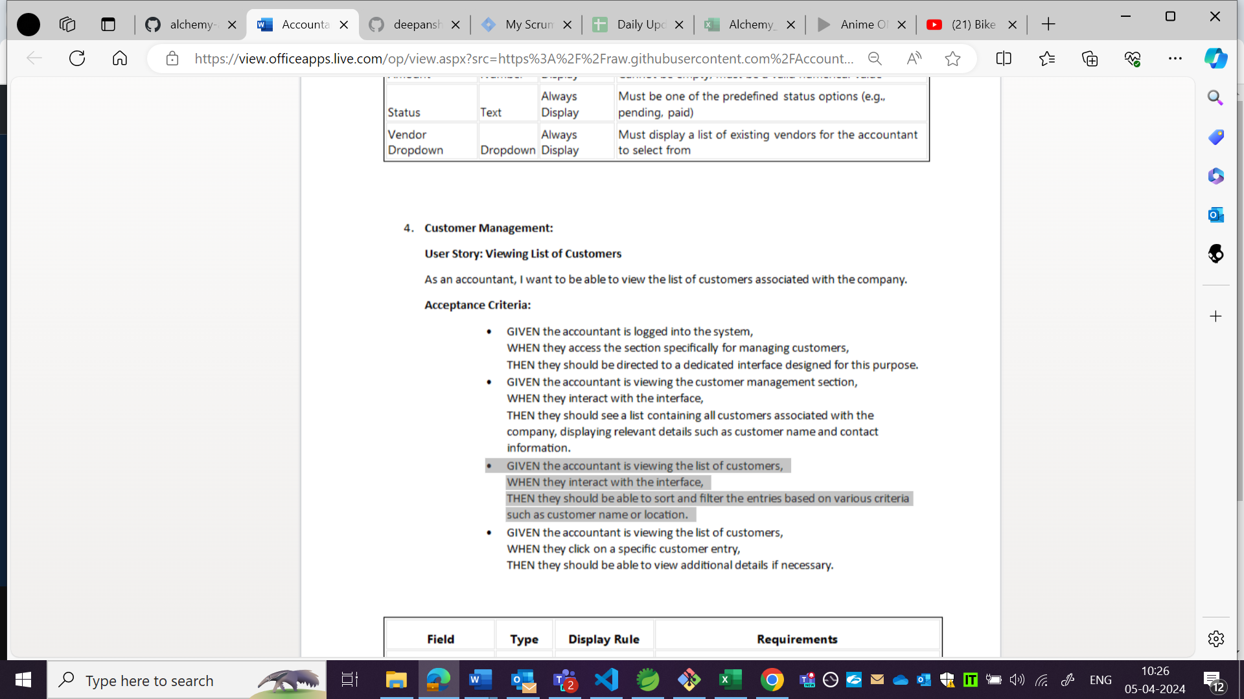

OBSERVATION5:

Content is not in tabular format.

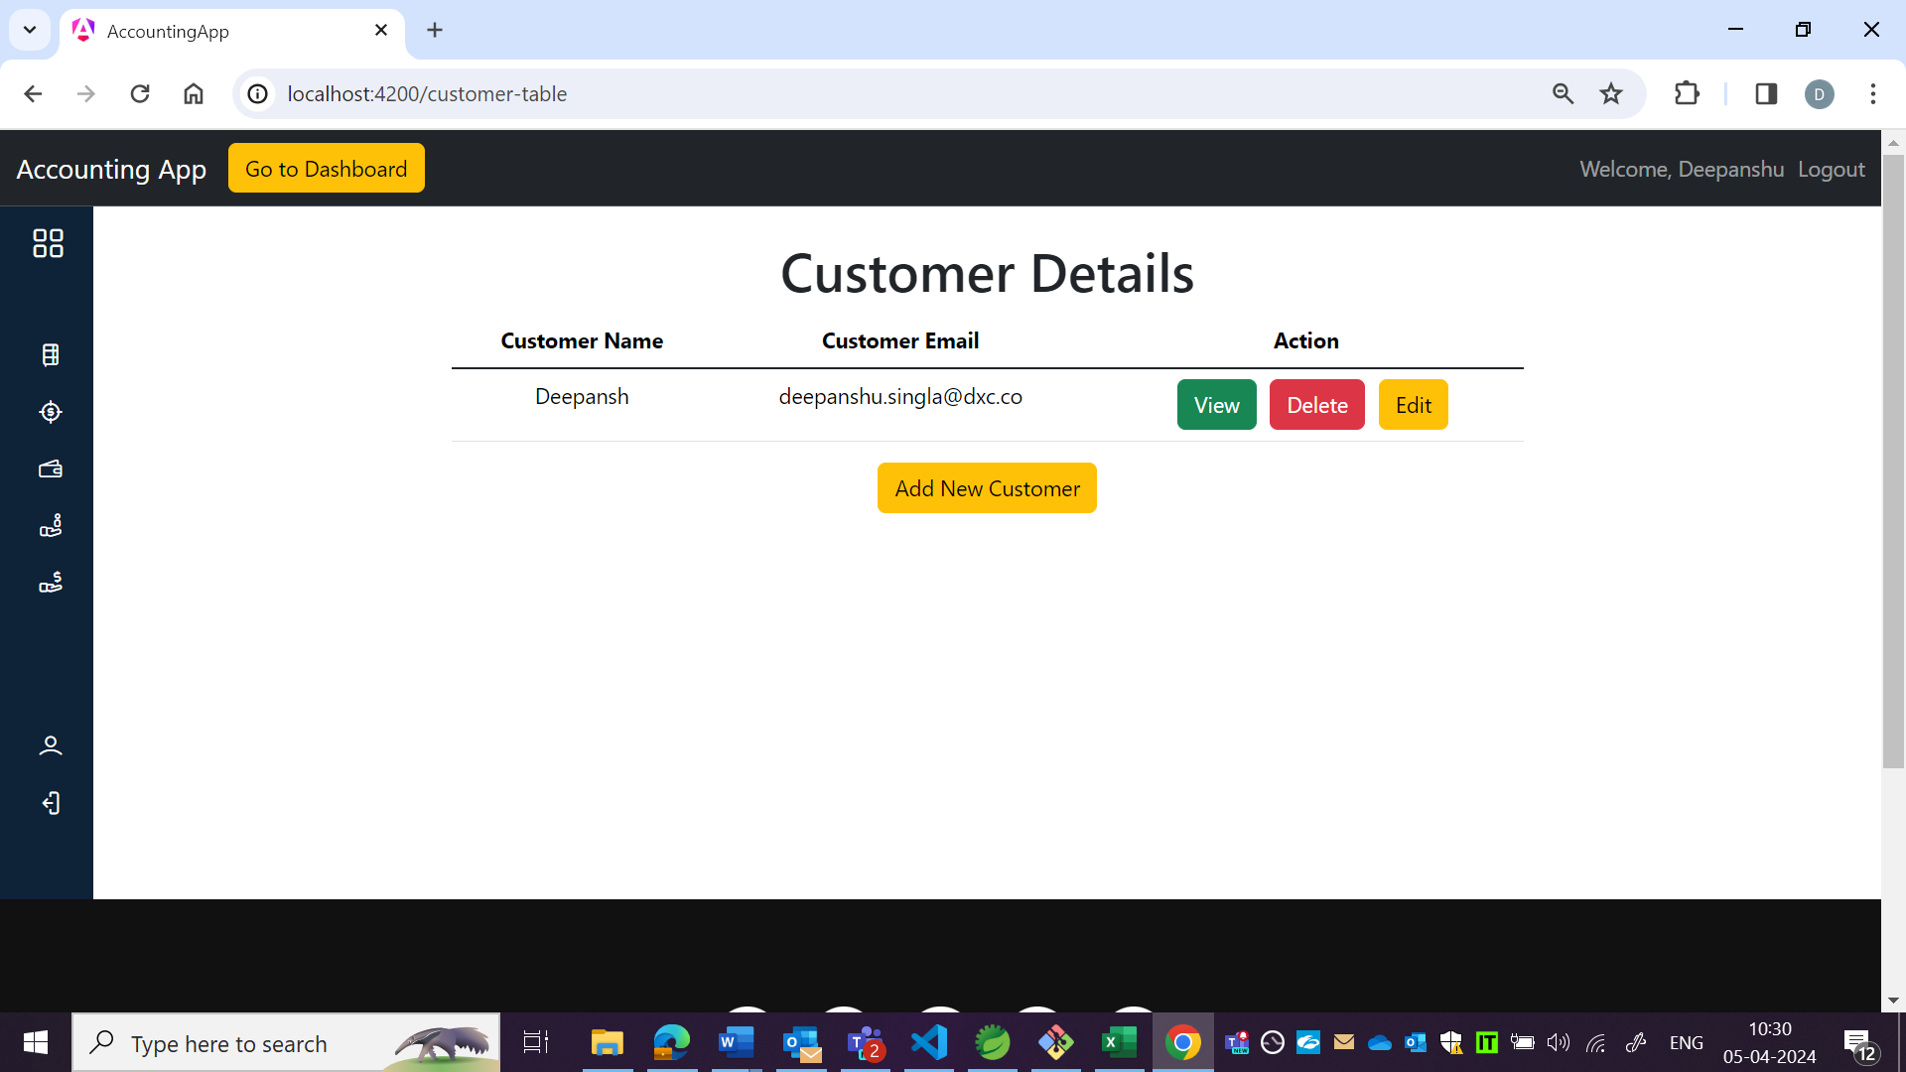

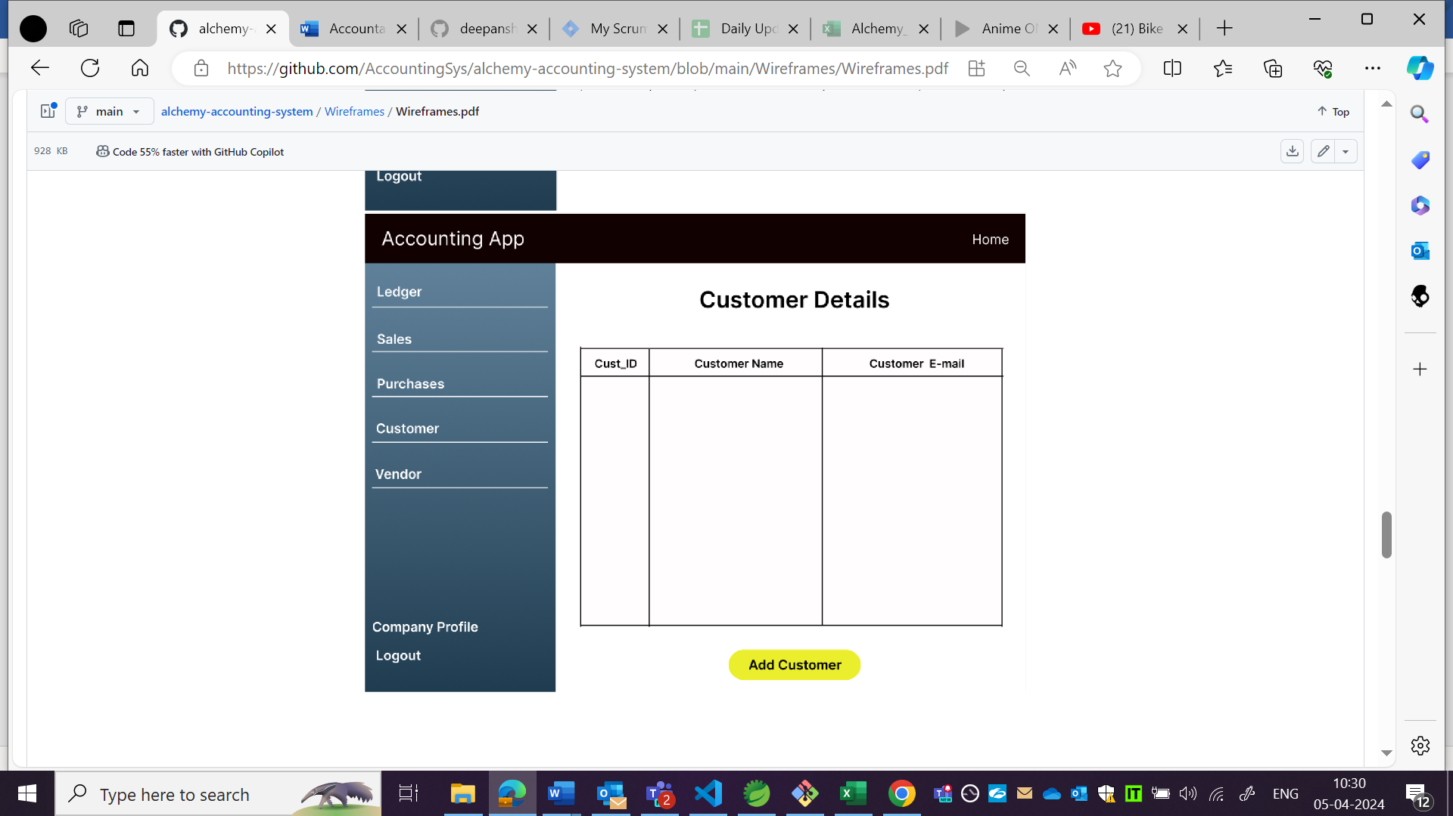

OBSERVATION6:

Background is not as per wireframe.

